NIM : 2802485113

NAME : Arief Arya Menon

Documentation

Header, is always sticks to the top of the screen



Navbar, main tool to navigate between pages

Footer, is always at the bottom of the page



# HOME PAGE

Hero section - to encourage users to join when they first enter the website, pressing the join membership takes you to the join membership page

Top 5 products section, hovering over a products blurs the rest to highlight the selected product. Pressing the view all products button takes you to the products page

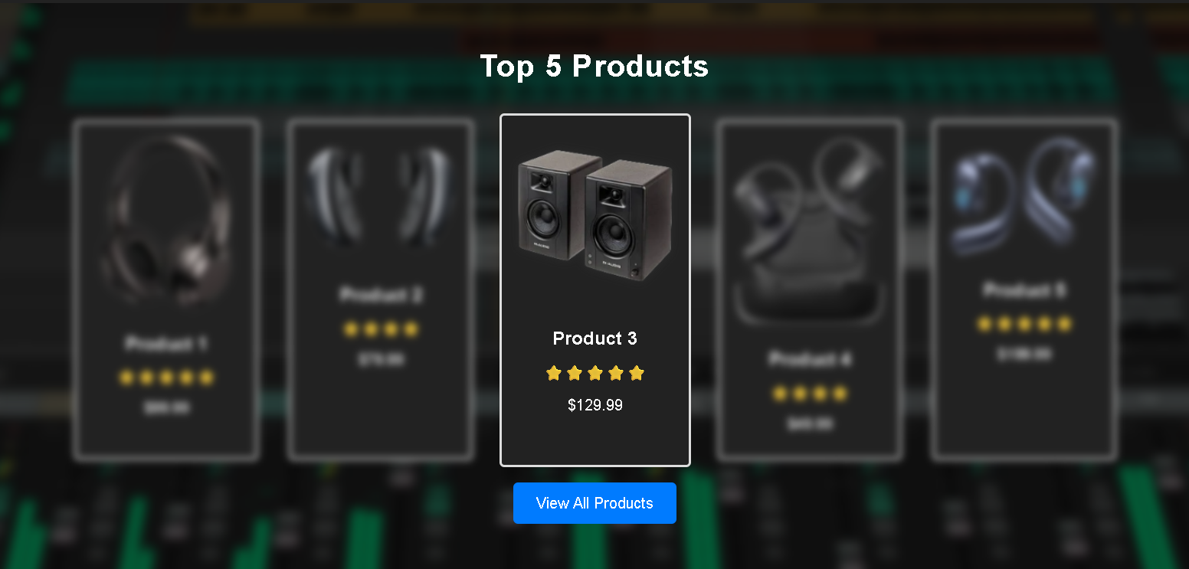

Current promotions section, hovering over a promotion blurs the rest to highlight the selected promotion. Pressing the view all promotions button takes you to the Deals page

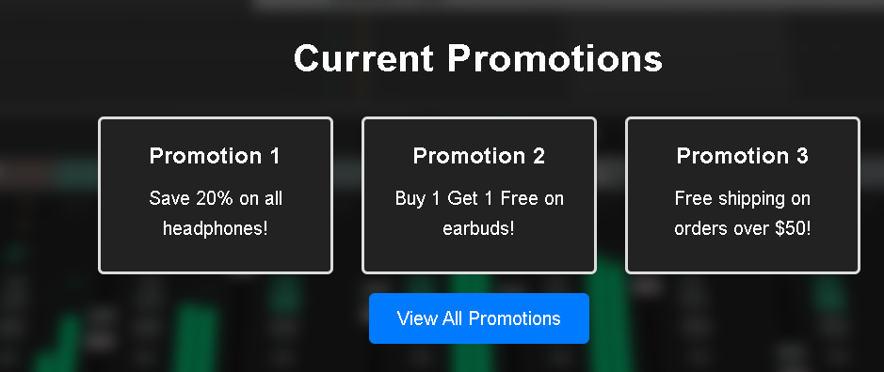

# 

# PRODUCTS PAGE

You can filter the products by its category,

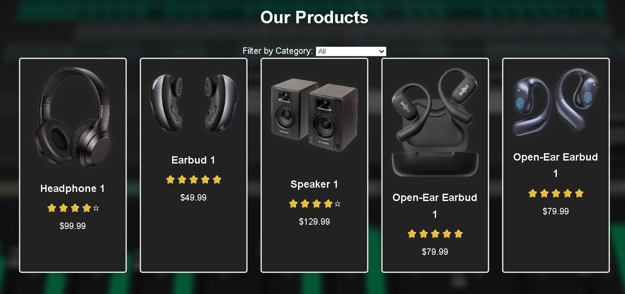

# ABOUT PAGE

About section with a centred logo and name, followed with the about text



# 

# 

# DEALS PAGE

Join membership hero prompt to encourage users to join for exclusive deals, pressing the join now button redirects to the join membership page



Promotion and exclusive deals for members display, hovering over a promotion or deal blurs the rest to highlight the selected promotion or deal.

Pressing the shop now button redirects to the products page.

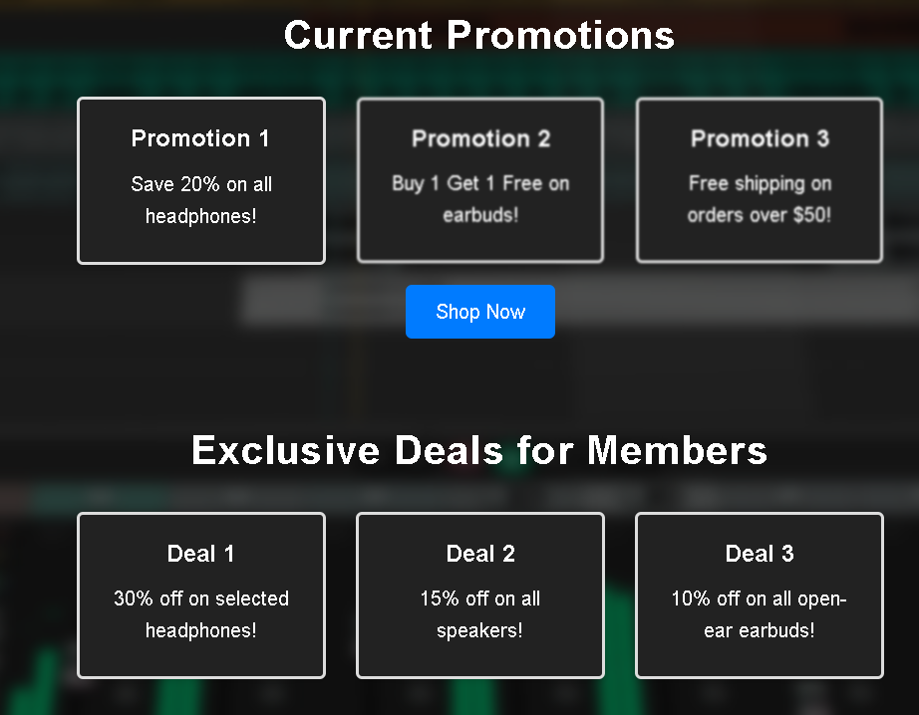

# JOIN MEMBERSHIP PAGE

Join membership form, with input validation for each part

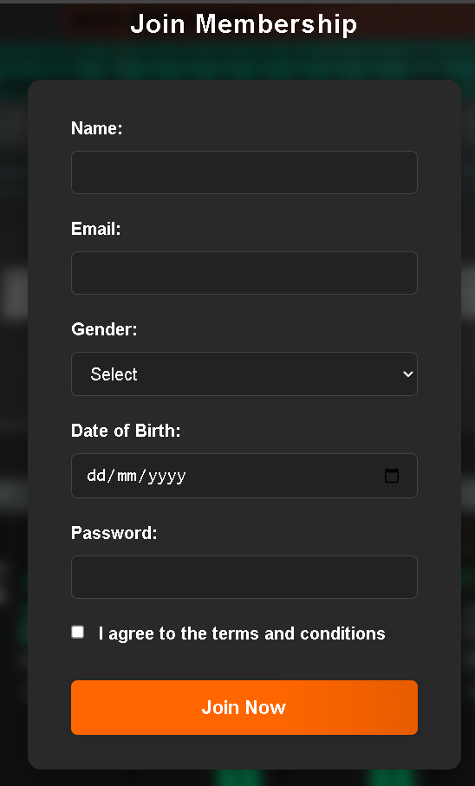

# Referensi

<https://www.reaper.fm/v5img/logo_sc.jpg>

<https://www.reaper.fm/v7img/ss_persp_v7.jpg>

<https://down-id.img.susercontent.com/file/id-11134207-7r991-lpehri148dxqca>

<https://encrypted-tbn3.gstatic.com/images?q=tbn:ANd9GcSOl1EqloTNNXB-HvA9Fc6iFQSD2HCDbTyxxxLHjUeMhVoCxjPY>

<https://static.wixstatic.com/media/ab602c_c54da886a09a44888f6747ee61951fd4~mv2.jpg/v1/fill/w_480,h_480,al_c,q_80,usm_0.66_1.00_0.01,enc_avif,quality_auto/ab602c_c54da886a09a44888f6747ee61951fd4~mv2.jpg>

<https://down-id.img.susercontent.com/file/id-11134207-7r98v-lvwlom8ixzbyc0>

<https://img.kentfaith.com/cache/catalog/products/us/GW53.0093/GW53.0093-1-518x518.jpg>